**Finding A Genre :  
PAGAN/TRAD/TRIBAL/MYTHICAL Sci-Fi**

**1.** **A Baroque world…** 2

**2.** **…inspired through Techno-Animism,** 3

**3.** **…Using Biopunk tech !** 4

**4.** **…Under Cosmystico-mythical-horror,** 5

**5.** **… in Silkpunk aesthetics,** 6

To make it simple, I think that **“Pagan” sci-fi** or **“Trad/Tribal” sci-fi** or **“Mythical” sci-fi** is the shortest way I can put it. You will see below it has 5 core elements which will define it much better:

**Baroque, Techno-Animistic, Biopunk, Cosmystico-mythical-horror, Silkpunk**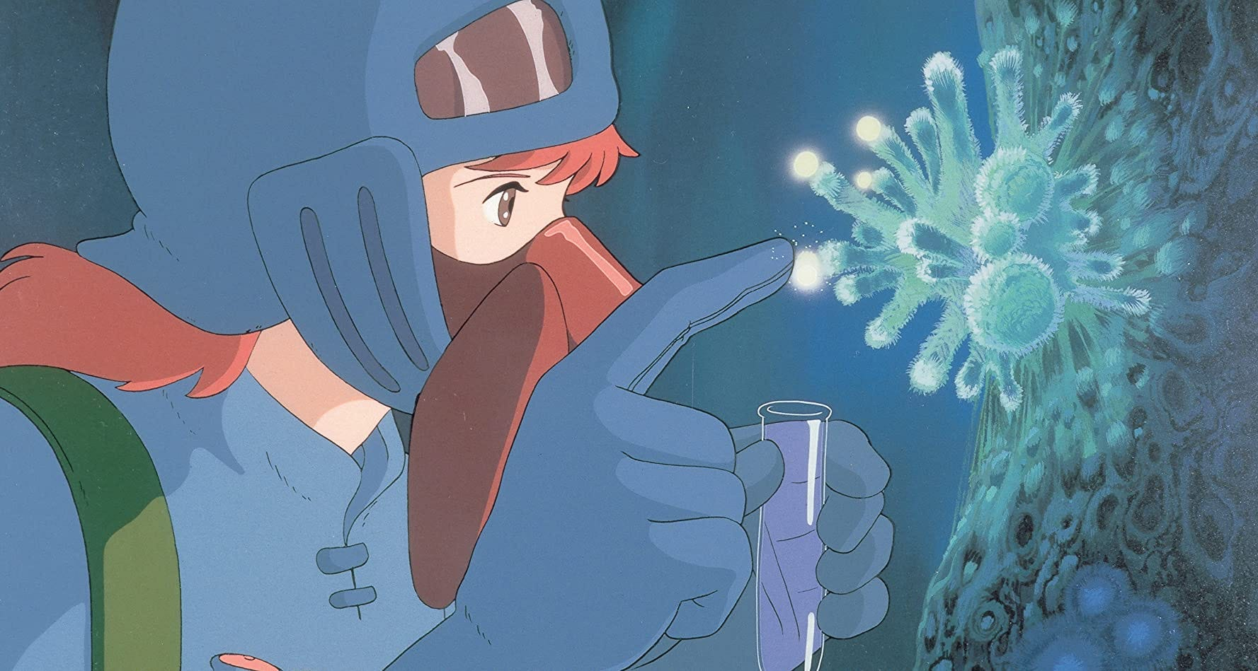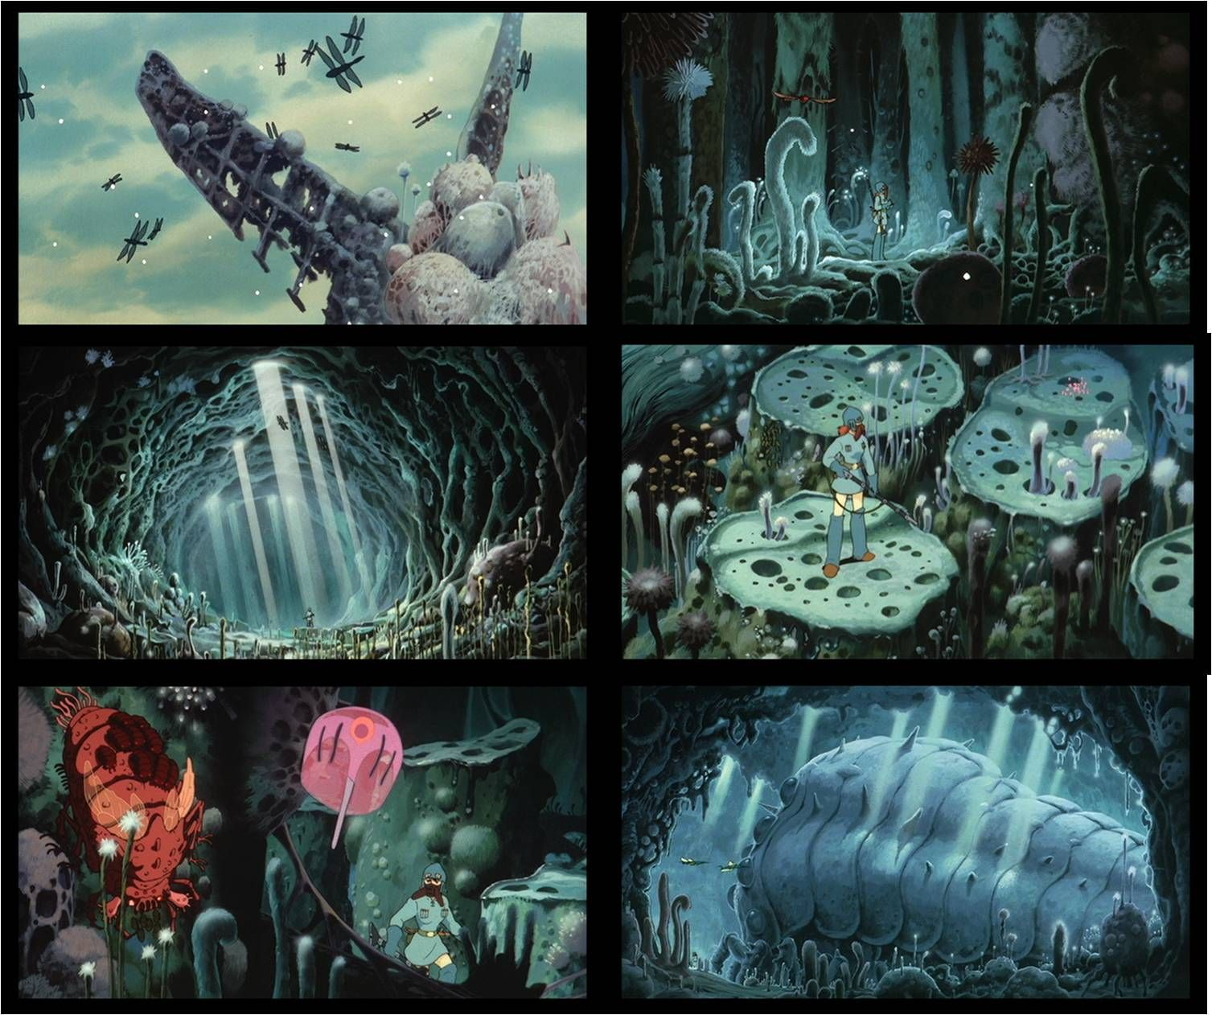

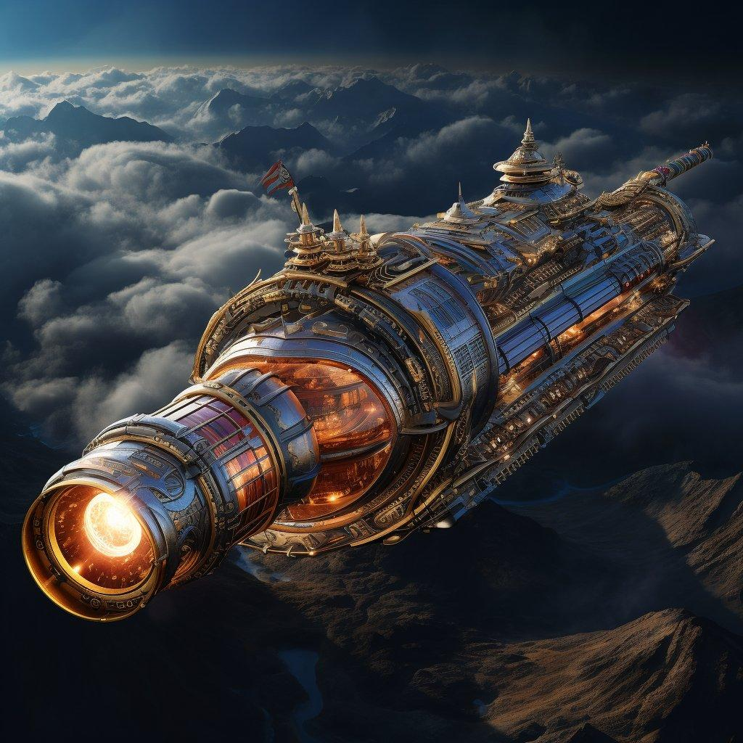

1. **A Baroque world…** 
   1. To break the common trope of sci-fi minimalism. Instead, everything is detailed and maximalist (not necessarily like the 17th c. style, but conceptually like it only). The closest I can find that has this aesthetic in sci-fi is Warhammer 40K’s spaceships for example, literal wandering church BUT our world won’t be such. As this “catholic” sci-fi has been made already in W40K, instead it will be… 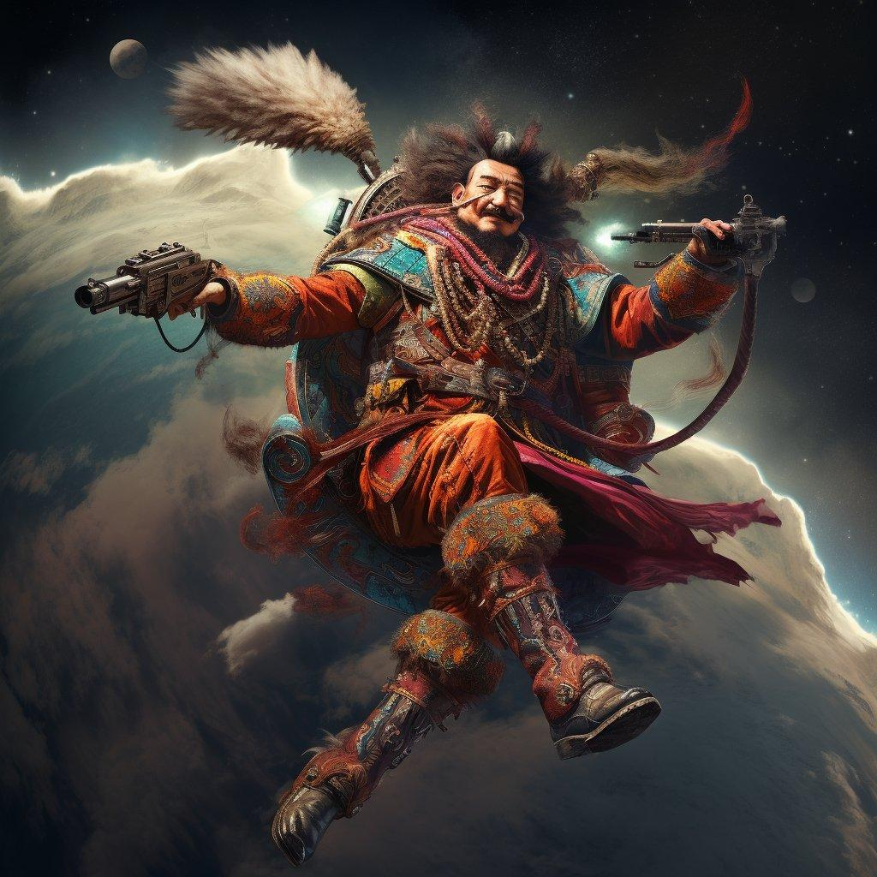
2. **…inspired through Techno-Animism,**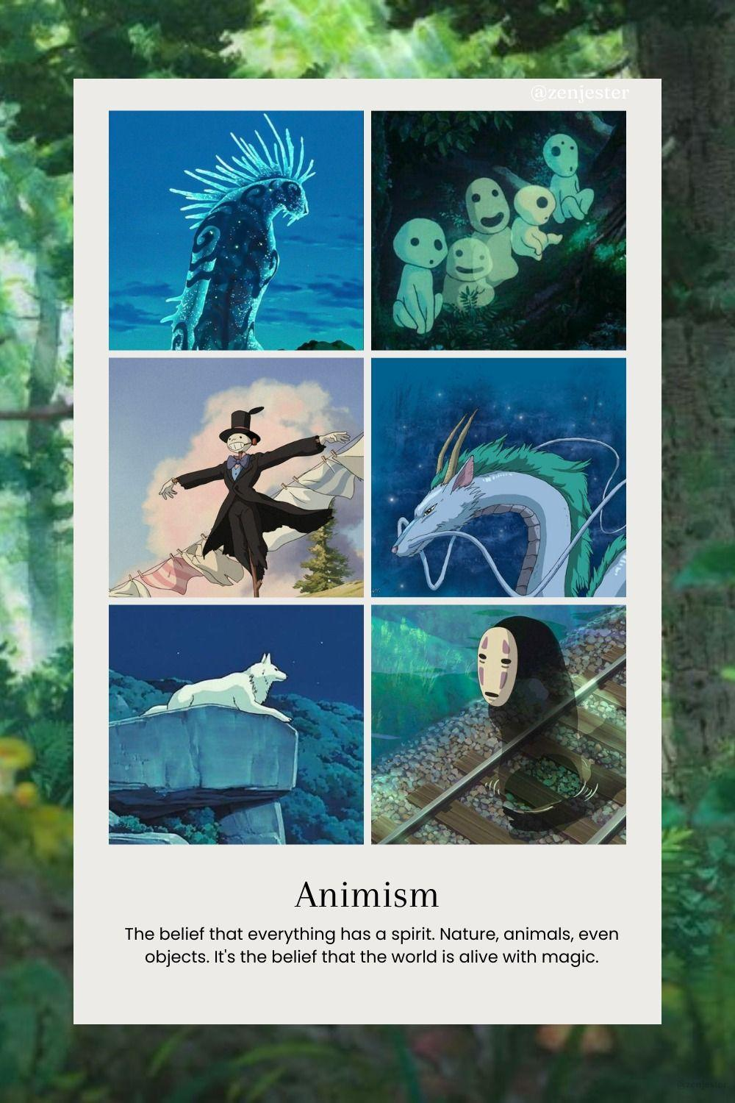
   1. The future is animistic guys. The oldest religion, the primordial one, we came back to it after all, but through technology and the future. *I know the pictures on the left are all cute which doesn’t fit what we need, but it’s just what I could find represents the concept best, which needs to be turned more horrific where it needs to be.*
   2. Everything HAS a “spirit”. What “moves” is proof that it is “alive” … Or at least we now mostly believe so, and there may be cyborg-shamans, and your dead rematerialized holographic-ancestors watching upon you – maybe reincarnating in you as well as sentient tumors.   
      You may perform Sacrifices towards such spirits so they may be nice to you in return, like invisible friends who can see what you do for them, and maybe hear and see your demands.
   3. *Your bottle has a spirit too, and the door as well, as you see these kinds of objects in your* ***dreams, visions, and hallucinations*** *as well, which IS the objective proof their existence in “the other world” which is here and there, but intangible and unseen in general, unless to select few.   
      It is “objectively proven”, as we have *now* scientifically observed that what we see in these conditions, has some actual impact on our life, and thus animism had to be brought back, and acting for the intangible and invisible isn’t as superstitious as before.*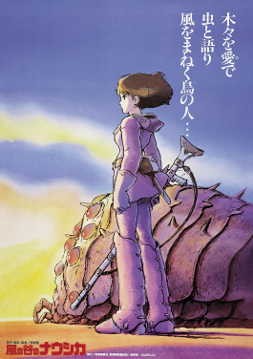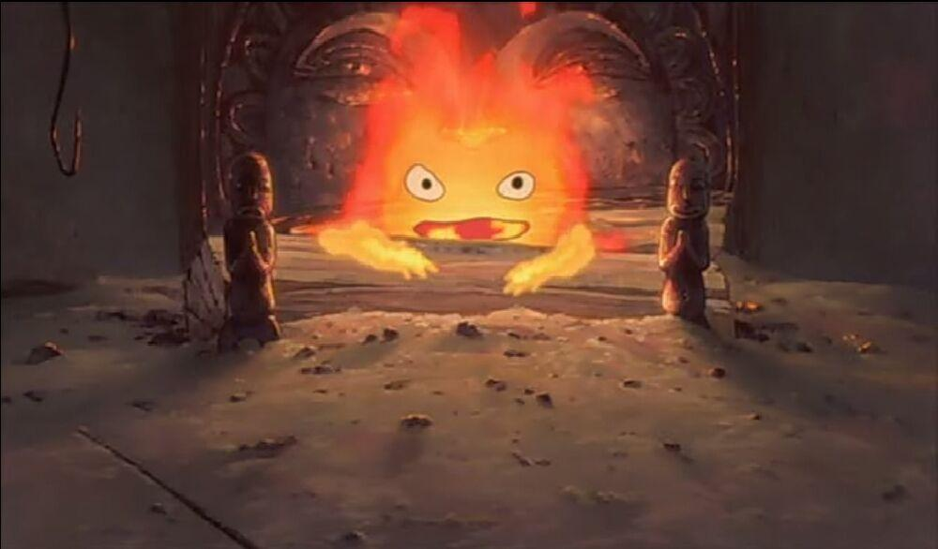
   4. This affected how we dealt with technology, and how we developed it. This may also affect how and why we interact with the reef. *Closest example are Ghibli movies such as Howl's Moving Castle’s “Calcifer” the fire has emotions and even eyes – it is both alive AND personified*.
   5. Transhumanistic animism wanted to bring consciousness to everything, technology yes, but bottles, walls, fire, stones, etc. Through genetic engineering, material and waves technologies, we either faked their consciousness or gave it to them, which leads us also to…

**Ghibli’s first movie, Nausicää, is probably the best fit of animism in relation to Evivrus (it literally has spore infections and alien fauna)**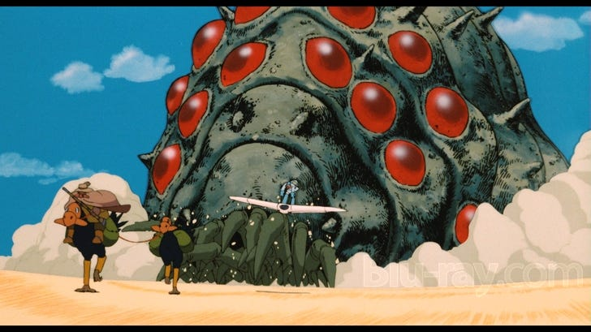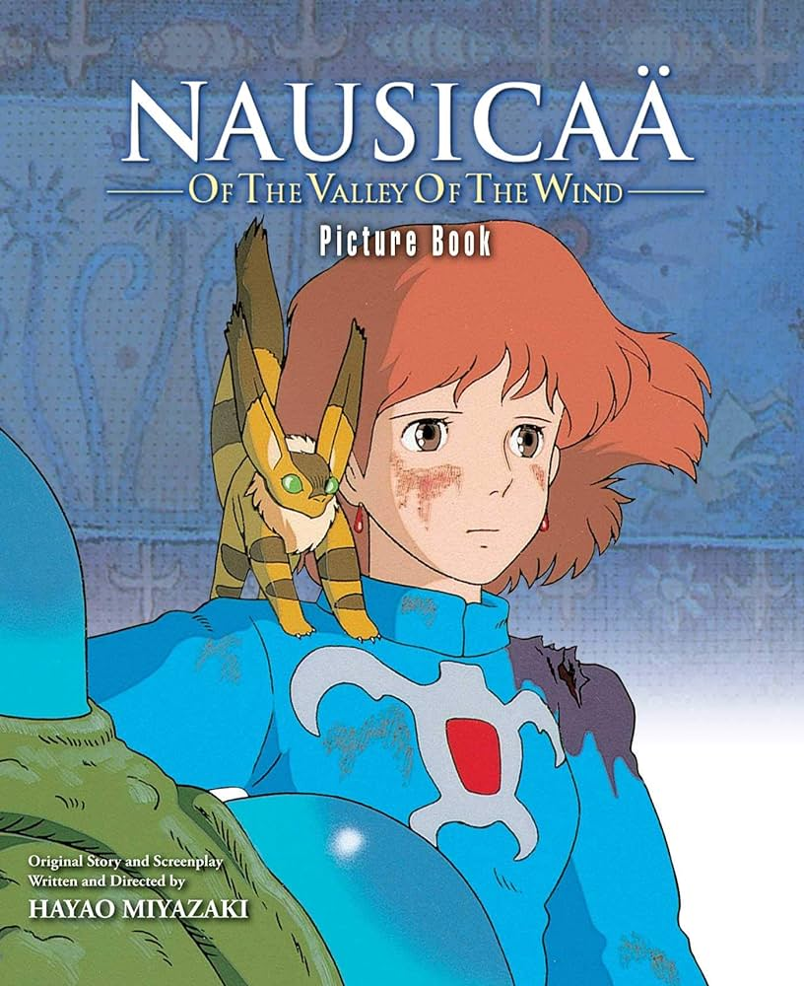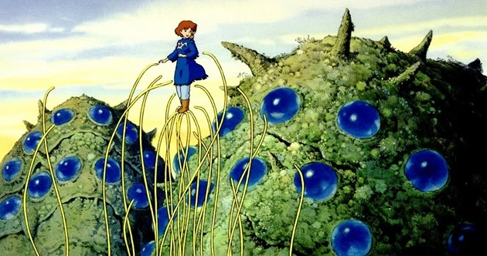

1. **…Using Biopunk tech !** 
   1. Tied to the Reef & technology, Man through biology increases himself, but not necessarily in the typically common trope of ugliness tied to Biopunk (why? Because WE play the humans so we must be “good” – the enemies WILL create the “horror” contrast). But we can if horror isn’t strong enough, of course.
   2. Humans: We can interact more deeply with certain items we have granted human-like traits through our techno-animistic worldview.  
      But also… Exploding larvae when thrown, Exoarmors made of an actual living genetically enhanced titanium-shelled millipede, etc.
   3. Enemies: Are naturally biopunk, but the “evil” version makes you feel odd or afraid. Doors made of organic-ventricle, Bodies turned into corals, Shrooms grows as walls, bioluminescent organisms as lamps, etc.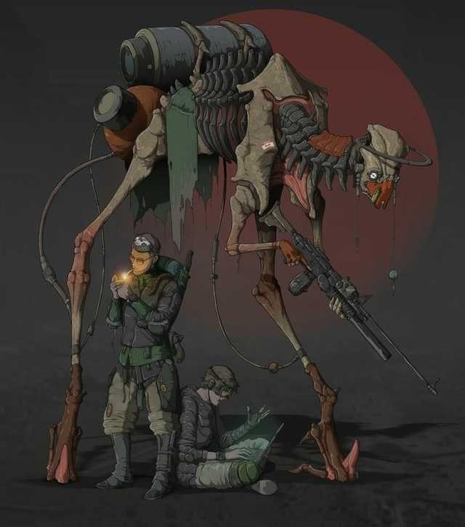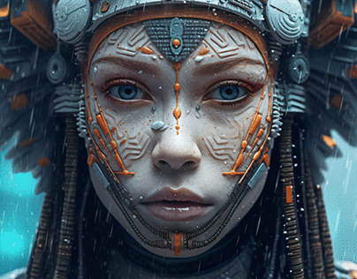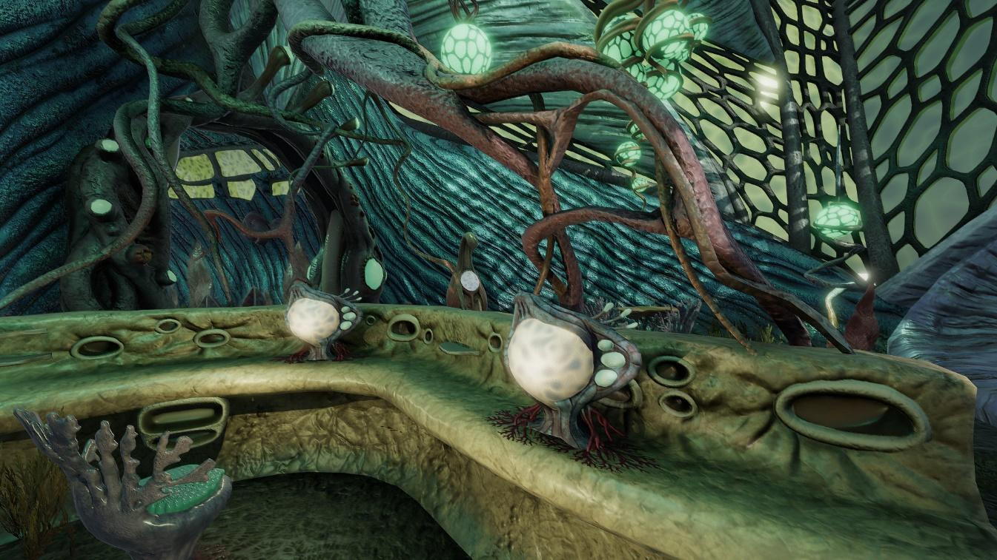
2. **…Under Cosmystico-mythical-horror,**
   1. Our most ancient myths but found in the cosmic sea instead. Have we been searching for “the gods” (aliens? actual gods? The nihilistic truth of the universe?). We can use the oldest proto-Indo-European, Siberian, Sumerian, etc. myths and horrors, that we translated through a futuristic horrific lore and beliefs and catastrophes. Basically, as inspiration.
   2. Everything must have meaning, symbolic or not, in the eyes of future humans seeking signs everywhere they may find. This is for the lorebuilding more than anything, I think.

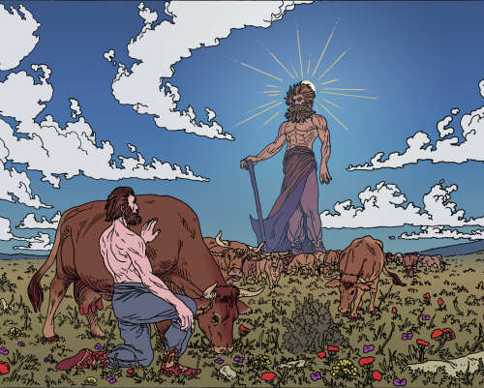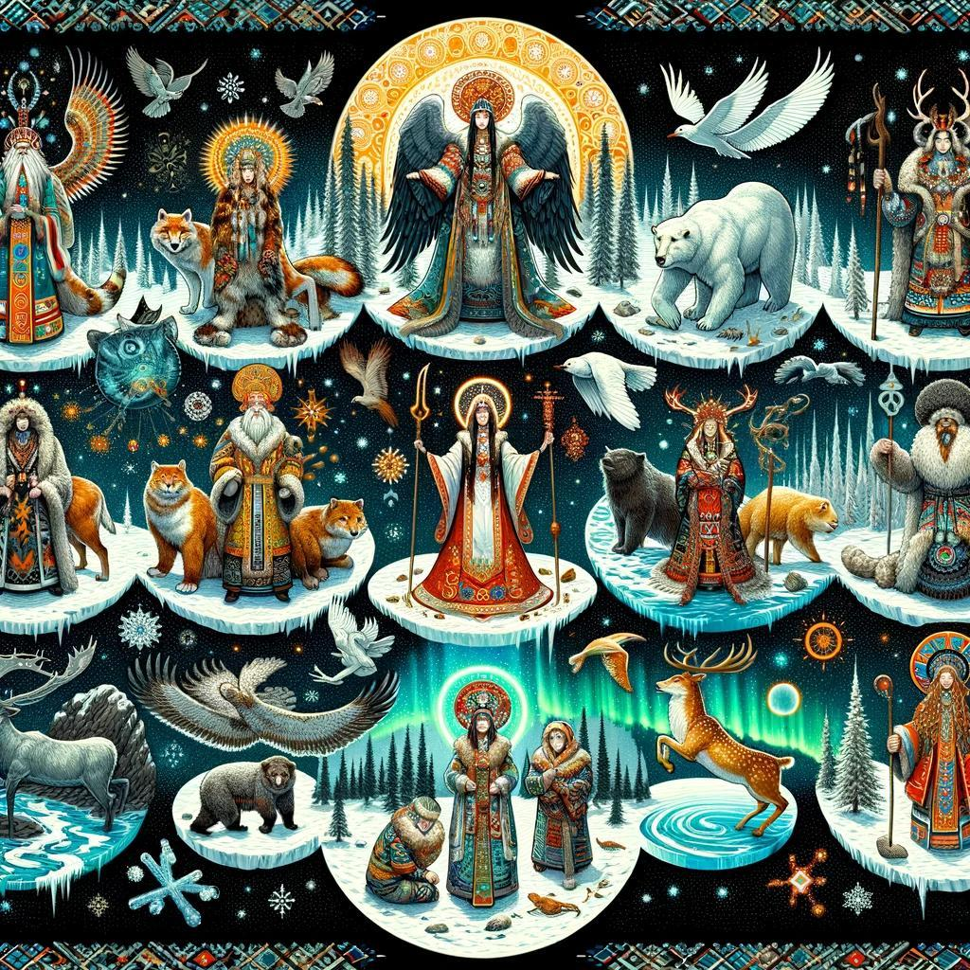

1. **… in Silkpunk aesthetics,** 
   1. Introducing the Silk-Road narratives but INTO the space “desert”. Caravanserai, Fortress in the deserts to provide essential resources to travelers and exchange spaceships in need of repairs or “gas”. Caravans of spaceships, trading between planets/ factions, etc.
   2. Aesthetics *inspired (only)* by Silk, Bamboo and Paper as well as other traditional materials from tribalism (shells, vernacular architecture, patterned symbolism, etc.) but in sci-fi.

***See below for “traditional material” references, which would need to be translated into sci-fi OBVIOUSLY – A bit like the picture right here which used the traditional but into sci-fi elements***



